# Documentation Barcode Scanner App

## Summary

This is an Android application for scanning UIC 918.2 and 918.3 specification Aztec Barcodes with the camera of a phone or tablet. For each scanned ticket, the properties and fields are shown. Additionally, public keys for validating ticket contents can be downloaded from the UIC website or added manually.

## History

NS has used an open source project, “Open918” ([www.open918.org)](http://www.open918.org)) as basis to complete the implementation. The user interface has been completed and support for UIC 918.2 tickets has been added. The license for the code is the BSD license, but it has not been published.

## App architecture

The app has several functions, but is split into two parts: the user interface/app and a parsing library. The user interface/app is in charge of scanning the barcode and converting picture data to binary data. The library converts binary data to fields and properties which the user interface can then show. All parts are implemented in Java and work on the latest Android Software Development Kit (SDK). Further development is recommended to be done using Android Studio 2.3 or later.

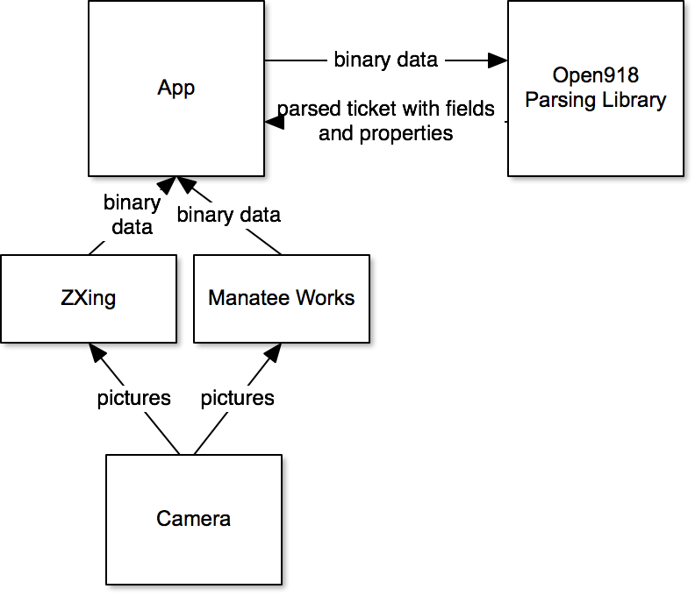

*App*

The app uses one of two scanning frameworks to turn camera pictures into binary data of detected barcodes. The user can choose which to use. ZXing is an opensource project (<https://zxing.org/w/decode.jspx>) with moderate support for Aztec barcodes. Manatee Works (<https://manateeworks.com/>) is a commercial toolkit with a license for a limited number of devices but vastly improved scanning (quality and speed). The Manatee Works toolkit is included in the packaged version of the app but not in the source code due to the license which must be purchased.

After the library (see below) parses the ticket, the app shows the result in several different formats. This includes a summary view, a table of each field and also the “ATB” representation of the fields rendered as text.

*Parsing*

This is a separate library and can be used to convert the barcode into fields, the most important part of the application. The goal is to be able to read as many tickets as possible and so several approaches are used. This has been tested with a wide variety of NMBS, DB, ÖBB, SBB, DSB, CD and NS tickets and supports all theses. The library may also be separated from the app and used for other validation purposes. Please not that this code cannot create the barcodes, this is not a feature.